***Chemistry notes:***

***Topic 7 – Organic Chemistry:***

**Hydrocarbons**

A hydrocarbon is any compound that is formed from carbon and hydrogen atoms only.

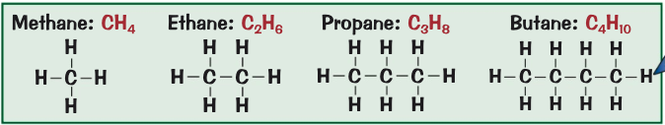

* Alkanes
  + Alkanes are the simplest type of hydrocarbon
  + General formula
    - CnH2n+2
  + Alkanes are a homologous series
    - This means that they are a group of organic compounds that react in the same way
  + Alkanes are saturated compounds
    - This means that each carbon atom forms with four single covalent bonds
    - The bonds are all single bonds
  + The first four alkanes are methane, ethane, propane and butane
* Properties of a Hydrocarbon
  + The shorter the carbon chain
    - The runnier it is. (less gloopy)
    - The more volatile it is. (lower boiling points)
    - The more flammable it is.
  + The properties affect how they’re used for fuels
    - Having a lower boiling point means they’re used as bottles gasses
      * Meaning they’re stored as liquids under pressure
* Complete Combustion
  + A close up of a sign

    Description automatically generatedThe complete combustion of any hydrocarbon in oxygen releases lots of energy
    - The only waste products are carbon dioxide and water
  + During combustion, both carbon and hydrogen from the hydrocarbon are oxidised
  + Hydrocarbons are used as fuels due to the amount of energy released when they combust completely

**Fractional distillation**

* Crude Oil
  + Crude oil is a fossil fuel
    - It is formed from the remains of plants and animals, that died millions of years ago and were buried in mud
    - Over millions of years, with high temperature and pressure the remains turn to crude oil which can be drilled up from rocks where it’s found
  + Fossil fuels like coal, oil and gas are non-renewable fuels as they take long so long to make that they’re being used up much faster than they’re being formed
    - They’re finite and one day will run out
* Fractional distillation
  + Can be used to separate hydrocarbon fractions
  + Crude oil is a mixture of lots of different hydrocarbons
    - Most of which are alkanes
  + Method:

1. The oil is heated until most of it has turned into gas
   1. The gases enter a fractionating column
      1. The liquid is drained off
2. In the column, there’s a temperature gradient
   1. This means that its hot at the bottom and cooler as you go up
3. The longer the hydrocarbon, the higher the boiling points
4. As the hydrocarbons go up, they condense back into liquids and drain out of the columns
5. You end up with the crude oil mixture separated out into different fractions

**Crude Oil:**